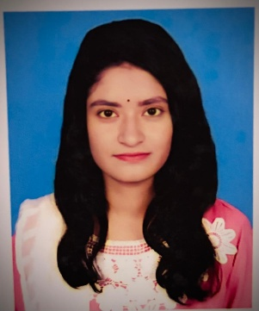
Choity Barai
Undergraduate Student
Jalirpar,Muksudpur,Gopalganj choitybaarai2234@gmail.com +8801748783406 https://www.linkedin.com/in/choity-barai-a52735367/

OBJECTIVE

To build a rewarding career in a dynamic organization where I can continuously learn, develop, and apply my technical skills in software development. I aim to contribute effectively to projects by delivering efficient and user-friendly solutions, while enhancing my expertise and supporting the organization’s growth and success.

EDUCATION
B.Sc. Engineering Jan 2023 - Present
Information & Communication Technology
Mawlana Bhashani Science & Technology University
Santosh, Tangail-1902.
CGPA: 3.52 out of 4.00
Relevant Coursework: Intro to Networking, , Operating System, C Programming,Java, Python, Data Structure, Algorithm, Basic Statistics, Database
Higher Secondary School Certificate (HSC) 2021
Science
Govt. Sarada Sundari Mohila College
Faridpur,Dhaka
GPA: 5 out of 5.00
Secondary School Certificate (SSC) 2019
Science
Satpar DNGC High School
Satpar, Gopalganj
GPA: 5 out of 5.00

EXTRA-CURRICULUM ACTIVITIES

Sports: Football, Cricket, Volleyball, Badminton

Cultural Activities: Singing, Dancing, Drama/Acting

Volunteering / Social Service

Debate & Quiz Competitions

Club Memberships: Science Club, Programming Club, ICT Club

Event Participation: Workshops, Seminars, Tech Fairs

TRAINING
Enhancing Digital Government and Economy (EDGE) | Python
Dept. of ICT, MBSTU
12 December 2024 - present
Topic Covered: Python django framework

PERSONAL INFO
Date of Birth: 15 March, 2003
Marital Status: Single
Nationality: Bangladeshi Permanent Address: Village: Jalirpar, Post-Oﬃce: Jalirpar, Muksudpur, Gopalganj.

STRENGTHS
Hard-working Communication Learner Creative
Teamwork
Time Management
LANGUAGES
Bangla Native or bilingual proficiency
English Full working proficiency

PROGRAMMING LANGUAGE





C










Java Python

HOBBIES
Drawing
Gardening
Traveling

